**[Mapping Tutorial: Symbols (Illustrator CS and above)](https://www.thepiazza.org.uk/bb/viewtopic.php?p=26578" \l "p26578)**

**Introduction**  
  
Symbols are an essential part of all hex mapping systems; they are the basic tiles that make up the map. There are various ways of dealing with symbols, and how they are used depends largely on the features of the program in question: does it use raster or vector art (or both)? Is there an easy way to snap the tiles to a hex grid? Is it possible to update the symbols without redrawing the whole map? And so on.  
  
My mapping system has seen two major revisions so far. The first version was started in Illustrator 8 back in 1999 but abandoned due to slow editing speeds. I resurrected it in 2005 and revised it to use the Patterns feature. This yielded some good results, but also numerous problems. The second major revision was made possible by the new Symbol feature in Illustrator CS, which solved most of these problems. (Illustrator 10 may also have had the Symbol feature, but CS was the first version I used that included it.) It also changed the way my mapping system works quite radically.  
  
This tutorial covers the use of Symbols in CS versions of Illustrator. I will write a separate tutorial at a later date to cover the previous system.  
  
**Basic Concepts**  
  
The concept of Symbols is quite simple: if there is a piece of art that you want to place multiple times in your artwork, you can define it as a Symbol. The definition is held in the Symbols palette, and you can place as many copies (aka instances) of it as you like; all the copies remain linked to the Symbol definition.  
  
Consequently, should you want to change any of your art, it's a simple matter of making the changes and then replacing the Symbol definition in the Symbols palette with your new design. All the linked copies will automatically update. This makes Symbols excellent for hex mapping, because you can revise your hex art whenever you like, and it will only take a few clicks to update each map with the new art for each hex.  
  
Symbols can hold both vector and raster art. My Symbols are all vector-based, which means they stay perfectly sharp no matter how far you zoom in, and you can generate a raster image at whatever resolution you like.  
  
One other thing to keep in mind is that Symbols reduce the file size of your maps, because the file only needs to keep one definition of the art for each Symbol on your map.  
  
**Using Hex Symbols**  
  
There is one major problem with using Symbols for hexes: all Symbols are rectangular, regardless of the shape of their contents. This means that it is not easy to slot them into place in the grid. (Note: CS4 revised the Smart Guides feature so that it's often quite easy to fit hexes to the grid, but it's also easy to get the alignment slightly wrong, so the advice that follows is still very relevant.)  
  
The solution is to start with a pre-constructed grid comprising of hexes (simple hex shapes with a thin stroke set to 75% Multiply Transparency on the Hex Grid layer) and Symbols (instances of the "Blank" Symbol, which contains an unstroked/unfilled transparent hex, on the Map layer). The grid is already in perfect alignment, and need only be copied and pasted (or trimmed) to the desired size. Aligning a copy of the grid involves copying and pasting both layers (making sure the Paste Remembers Layers option in the Layers panel options is ticked), making sure you have both layers of your copy selected, and then using Smart Guides to line up the anchors of the hexes so that they snap together perfectly.  
  
Once your grid is in place, you won't be doing any more placing of hexes; from now on, you will instead select an existing hex Symbol and use the Replace function to replace the Symbol with whatever symbol you want. In Illustrator CS, CS2 and CS3, this involves selecting the hex Symbol(s) on your map that you want to change; clicking on the new hex art in the Symbols panel; and finally clicking on the "Replace Symbol" button in the middle of the bottom line of buttons in the Symbols panel. In CS4, this button has vanished, but there's now a new Replace Symbol button on the context-sensitive Control Panel (under the menu bar - the one that changes depending on what you have selected).  
  
That's basically it. You can continue selecting and replacing symbols until your map is complete.  
  
**Advanced Usage**  
  
Coming Soon.  
  
(This section will cover how to replace symbol definitions; how to select all of one symbol type; how to edit symbols; how to rename symbols and so on.)  
  
**Notes**  
  
This post is a work in progress. I hope to add some illustrations, but for now I'm out of time.  
  
Please let me know what you think! If some parts are hard to understand, let me know and I'll have another stab at explaining. Would it be easier if I included numbered lists of instructions to follow - perhaps in addition to the current text, as a summary for reference?

<https://www.youtube.com/watch?v=f1LcfPKW-2Y> For hexes, and how to use hex symbols. He is even using Thorf's tools!  
  
  
<https://www.youtube.com/watch?v=gKATk8uW2Lc> This one isn't about hexes, but looks great for tracing maps, drawing coasts and rivers, and using layers.

inkscape_hexmap_template_2013_02_15.svgz  
[https://drive.google.com/file/d/1zalNO1 ... sp=sharing](https://drive.google.com/file/d/1zalNO1i3oooFnZvsm72O_qVEMq9gv6b2/view?usp=sharing)  
And if you're wanting to add text, you might be interested in MyZtaraSmooth, my attempt at a Feinen-like typeface:  
[viewtopic.php?p=117850#p117850](https://www.thepiazza.org.uk/bb/viewtopic.php?p=117850#p117850)

### [Mapping Tutorial: Layers](https://www.thepiazza.org.uk/bb/viewtopic.php?p=25946#p25946)

**Introduction**  
  
I often think that the original TSR hex maps must have been done using multiple sheets of transparent paper, because they seem to have an internal logic as to what symbols appear on top of what. There are also lots of cases of elements being misaligned.  
  
As it happens, this is precisely how maps are made in the computer, whether you use Photoshop, Illustrator, or another program altogether. In this short tutorial I will introduce the concept of layers, and outline the system I have devised for my maps.  
  
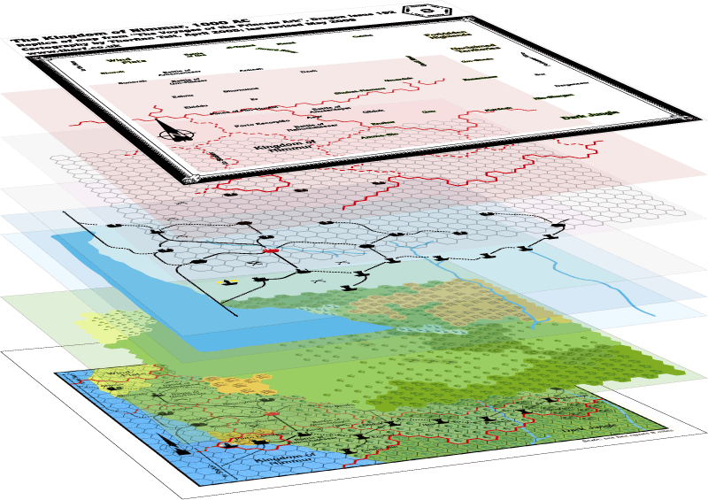  
*All the layers used to make an overland hex map.*  
  
**Map Layers**  
  
I have come up with an eight-layer system for making hex maps.  
  
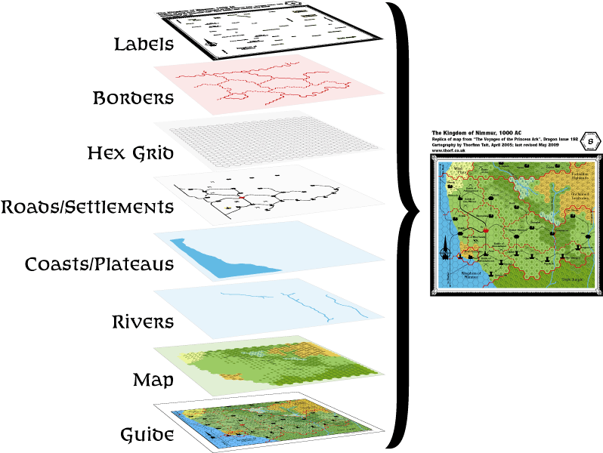

1. Labels - all text, map labels, compass roses, scale markers and borders go on this layer, on top of everything else.
2. Borders - country and dominion borders go on this layer, so that they overlay the hex grid.
3. Hex Grid - the home of the grid overlay which forms the basis of the map. The grey hex grid is set to "multiply" transparency at 75% opacity so that it merges nicely into the colours underneath.
4. Roads/Settlements - roads, trails and shipping trails, as well as settlements, battlefields, and other terrain feature icons are placed here to prevent them from being obscured by coasts and rivers.
5. Coasts/Plateaus - all the coasts and lakes along with plateaus and other non-symbol terrain features go on this layer. Masking map tiles are also sometimes placed here when drawing plateaus.
6. Rivers - all rivers and other such line-based water features go on this layer.
7. Map - this layer is for all the basic hexes that make up the bulk of any map.
8. Guide - the bottom layer, usually empty in my map PDFs. This is where I place scans and other source images which I want to trace.

That's basically it. If you make sure the elements are on the right layers, everything should fall into place nicely.  
  
There are some exceptions to these rules. For example, on some maps where a border crosses a hex tile, we want to make sure that the settlement icon on that tile doesn't get obscured by the border, so we put the settlement icon on the Labels layer. Similarly, markers for rapids and waterfalls usually go on the Roads/Settlements layer, but can be placed on the Labels layer if necessary.  
  
**Working with Layers**  
  
The most important technique for working with layers is turning them on and off. A good example of this is aligning a guide image to your map: by turning off all layers except Guide and Hex Grid, it becomes reasonably easy to resize any guide images to the same proportions as the map. And of course it's usually best to leave the Map layer turned off while tracing from the Guide layer to any layer above.  
  
Finally, I have found that it's best to draw replica maps from the top layer down to the bottom. Sticking to this order makes it easier to see where you are, and leaves the potentially memory-hogging map tiles to last. If you do encounter memory problems, it's always possible to export/copy and paste a layer to another document, work on it there, then import/copy and paste it back in. This is especially easy in Illustrator if you tick the "Paste remembers layers" option in the Layers panel options and then use CTRL F or CTRL B to paste in front or paste behind (these latter functions paste objects to the exact position they were copied or cut from - even if you paste them into another image).  
  
**In Conclusion**  
  
That's all I can think of for now. I hope some of you find it useful (or just interesting).  
  
If you have any questions about this topic, please feel free to ask in this thread. I'm sure there are various aspects of working with layers that I haven't thought to mention.  
  
I will update this first post periodically with new info as it comes up.

In any case, there are multiple quite complex things going on here that make revisions difficult. The first is that the hex art as it exists on official maps is neither specific nor very scientific, instead dealing effectively in stereotypes of terrain. It’s also designed for gaming rather than as a representation of actual terrain. The best example of this, really, is light vs. heavy forest, which a quick Google search will reveal is not in fact a distinction used in the real world; rather, it’s a conceit used for gaming, where the terrain type mainly affects two things: movement rates and (wandering) monster types.  
  
The second thing is that hex terrain types are not the same as the symbols on other maps — even other fantasy maps. The most obvious evidence of this is that the rigid grid is not to be taken at face value; Mystara’s terrain is not, in fact, divided into hexagonal blobs! What this really means is that each hex symbol shows the predominant terrain in that area. So for example a mountain hex is not necessarily going to be mountainous terrain from edge to edge; if it stands on its own in the middle of lower terrain, it likely represents a small outcrop of mountains, or perhaps even a single peak. On the other hand, surrounded by other mountain hexes it could well be a continuous area of mountains and valleys. In both cases, other terrain could still exist within that hex — the valleys are one obvious example, and there could well be a significant flat area within those mountains.  
  
Finally, the evolving nature of the symbols makes it problematic to try to interpret what the original designers really had in mind. Forested hills were a later invention, and even though technically they appeared in GAZ1’s legend, they weren’t really used until GAZ3. Does that mean Karameikos has no forested hills? Of course not.  
  
Similarly, the pine tree icon only appeared as late as 1992, in HWR3. Consequently, the vast majority of Mystara’s maps only used the oak tree symbol for their forests. Well, that and the palm tree for jungles.  
  
And as we know, none of these is necessarily the best solution for marking biomes. If I were to create a new system nowadays, I’d likely reference real world forest types, dividing them up by the various biomes present in the real world. But modifying the current system to fit this new ideal is problematic at best, because it means revising all of the current maps — and in many cases there is really no data to decide what to put where. On the other hand, we do now have climate maps of the world, and we could certainly make a decent job of it ourselves, I’m sure. But it would be quite a lot of work.  
  
Further complicating this is the regional nature of each of us’s knowledge of terrain. So for example the changes that you made for your North America hex map are surely good for that area, but may be less useful for mapping other continents.  
  
Lastly, I dislike the forested mountain symbol. The reason is very simple: it makes it much harder to see where mountain ranges lie. The advantage of the single brown shade for all mountains is its clarity. You can clearly see at a single glance which parts of the map are mountainous and which are not. (The original hills hex remains useful for the same reason, although I think the boat has long ago sailed on this issue with the introduction of forested hills.) Forested mountains usually have a darker shade of green, but this marks them as a kind of forest rather than a kind of mountain.  
  
Note that where I live in Japan, the mountains are basically all forested like this, and they are indeed a shade of dark green. But in terms of hex maps, I don’t think the distinction works like we want it to.  
  
One way to solve this would be to keep the brown background while adding tree symbols, perhaps in shades of dark green — which I have actually already experimented with, and so far rejected because I couldn’t get it to look right. I’ve seen others wrestling with this, too, including attempts to use a median shade between brown and green — an admirable idea, but another which was abandoned because it didn’t look right. I agree that the hexes are an abstraction and not really useful for anything than in game travel, random encounters and war gaming decisions. Would a hierarchy of terrain from the old 1980's to help with conversions and understanding? I'm not sure if the earlier map designers were so formal but what I envision would be something like this (I might be missing a terrain or two):  
Mountains > Hills > Forests/Swamps/Desert/Grasslands > Clear Land > Water(Maybe just clear land).  
When using this system, when they drew the map if there was any mountains in an area it took precedent (unless maybe just 1 mountain). If hills, then hills. If anything other than cleared flat land, then the other terrains. I don't think any of the early 1980s maps had mixed terrain so if you went into a hex it was mostly that terrain. Later you get forested hills, forested swamps and what not.  
  
I'd love detailed write ups of area, but I don't feel like that's going to happen. I might work on that after I get done with my version of the known world map though that could take a while. I might just approach it piece by piece where my campaign goes. As for a write up I think I'd use something like [this wikipedia page](https://en.wikipedia.org/wiki/Southern_Great_Lakes_forests) as an out line, but then add in some crunch/rules specifics.

DJShade (Birchbeer)